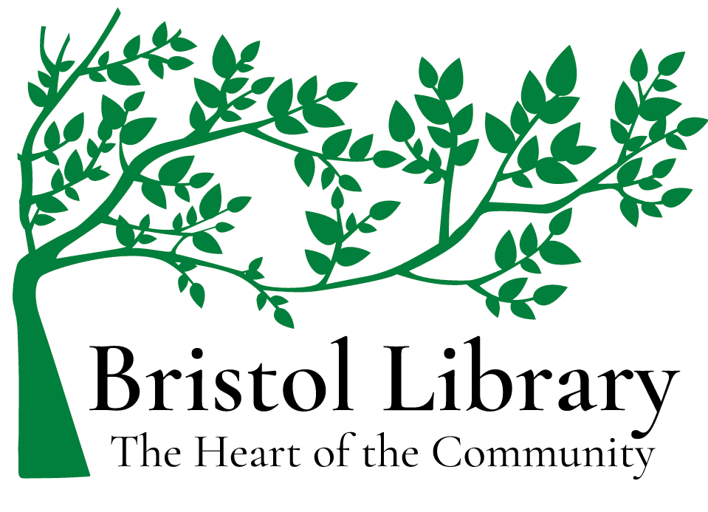
6750 County Road #32, Canandaigua , NY 14424

The Bristol Library

Five-Year Plan

2023-2028

VISION
Bristol Library – The Heart of the Community

MISSION
The Bristol Library brings people, information, and ideas together to enrich lives and build community.

HISTORY – BACKGROUND
The Bristol Library has been a community cornerstone in Bristol for over 100 years. Founded as a small, rural association library, the Bristol Library was awarded its absolute charter from the State of New York on June 15, 1915, to serve the residents of the Town of Bristol. It was first housed in Mrs. Fisher’s dining room. Years later, an old blacksmith shed was rolled on logs down the road and situated across Bristol Valley Road from the Methodist Church where it served the dual purpose of post office and library. In the early 1990s, the building was once again rolled down the road, this time on a truck, and around the corner to its current location. The Bristol Library has been at the present location on County Road 32 since 1993. The population of Bristol has remained steady with a little less than one percent decline since the 2010 Census.
The library provides services for four communities: Bristol (2,284 resident), South Bristol (1,641 residents), Bloomfield (East and West, totaling 6380 residents), and Richmond (3380 residents). The population in this area has remained steady, with 2% overall growth since 2010. The Bristol Library is located within the Bloomfield School District in the Town of Bristol. The Bloomfield Public Library and the Allens Hill Free Library are located in Bloomfield. The Honeoye Public Library is located in the Town of Richmond. South Bristol, located within the Naples School District, does not have a library within its town limits. Although there are other libraries that serve these areas, the Bristol Library is closer to many of the residents of Bloomfield, Richmond, and South Bristol.
The Bristol Library has an onsite collection of over 9000 physical items (print, audio, and video) and access to over 45,000 electronic materials (including e-books, downloadable audio/video collections, digital photographs, documents, and maps). The library collection includes best-selling fiction, classics, and everything in between. The Bristol Library loans books for all ages in regular and large print, audiobooks on CD, magazines, DVDs (including new releases as they are released), and downloadable audio- and e-books; it circulated 8605 items in 2022, with approximately 3,106 patron visits. The Bristol Library goal is to double the number of items circulated and patron visits and surpass pre-COVID levels by 10%–20%. In 2022, for example, the Bristol Library offered 133 programs, up 60% from pre-COVID years. The Bristol Library is a member of the OWWL Library System, which includes forty-two libraries from Ontario, Wayne, Wyoming, and Livingston counties and allows for free collection sharing among these member libraries.
Libraries are evolving. Libraries not only provide more information digitally, especially audio- and e-books, accounting for a national trend in patron growth, but they also provide innovative programs to accommodate a variety of community interests and are a hub for basic services. This latter function is especially important in small towns and rural areas. For example, during the pandemic Bristol Library provided internet access to fill the technology gap in our community for school children, remote workers, and others, as well as free COVID tests. In addition, Bristol Library provides voter registration, copy and fax services, zoom and high contrast keyboards as well as large print computer keyboards for differing visual abilities, and free Wi-Fi within the building. The Bristol Library continues to change as the needs of the community change, reflecting the needs of young readers, changes in technology, as well as the area’s boom in an aging population.

Bristol Library Values

The Bristol Library supports intellectual freedom and promotes literacy, a love of reading, and respect for the entire community. As a community center, Bristol Library embraces innovation and adapts programs and technologies to foster connection, personal growth, and a healthy democracy.
Intellectual freedom
The Bristol Library supports intellectual freedom and strives to enable all individuals in our community to exercise their right to access information.

Literacy and a love of reading
The Bristol Library recognizes the vital importance of reading to open doors and expand horizons and strives to support every patron in becoming a lifelong reader.

Community connection
The Bristol Library embraces the entire community and celebrates our town’s diversity such that all people feel welcome in the Bristol Library. We strive to meet the needs and expectations of every patron. The Bristol Library actively supports efforts that combat prejudice, stereotyping, and discrimination across race, ethnicity, gender, age, education, religion, ability, and income.

Strong partnerships
The Bristol Library extends its reach and impact in the community through collaborations with individuals, public and nonprofit agencies, local community groups, educators, and businesses.

Children, teenagers, and young adults
The Bristol Library joins parents, educators, and young people in helping to encourage the growth of thoughtful readers and citizens. We recognize the priority of efforts to close educational achievement gaps.

An age-friendly community
The Bristol Library is committed to bringing people of all ages together around shared interests, providing services, settings, and structures that promote independent living and staying connected to friends, family, and community.

A healthy democracy
The Bristol Library is committed to fostering democracy through building an informed community and providing neutral ground where participation in civic life is open to all.

Innovation
The Bristol Library continuously adapts what we do and how we do it to stay relevant to patrons’ changing needs and interests. We are a learning organization and invest in our staff, technology, and infrastructure to improve service.

Bristol Library

Value-Based Goals

Action Plans

Bristol Library is an organization that values intellectual freedom, promotes literacy, and recognizes the vital importance of reading to create opportunities and expand horizons.

Our goals include:
- providing access to information both in print and electronically that meets the needs and demands of patrons;
- using a data-driven approach to usage and requests to maintain a balanced collection;
- increasing library usage to above pre-COVID levels.
Action Items
- Provide a diverse and robust selection of books in a variety of formats.
- Provide computer service and internet connections.
- Participate in OWWL’s books-by-mail initiative (owwl.org/booksbymail/).
- Develop and implement programs that encourage reading across race, ethnicity, gender, age, education, religion, ability, and income.
- Expand our social media and other marketing efforts to raise Bristol Library visibility and community participation.
- Expand our collection in response to patron interests.
- Affirm the American Library Association’s advocacy of the rights of individuals to form their own opinions about resources they choose to read, view, listen to, or otherwise access through the library with responsible rules for patron use of the library.
- Continue to pursue funding for additions to collection.

Bristol Library is an organization that values strong community partnerships and community engagement.

Our goals include:
- promoting the library as a gathering place for patrons and community groups;
- offering a lecture series of speakers, authors, historical re-enactors (working in collaboration with local historical societies and other community groups);
- developing joint ventures, partnerships, and Library-on-the-Road programs that extend library resources through relevant book displays and lending and library registration opportunities at events for community organizations, such as Bristol Hills Historical Society, Cumming Nature Center, 4-H Camp Bristol Hills, South Bristol Fish and Game Club, Ontario County Arts Council, South Bristol Cultural Center, Bristol Volunteer Fire Department, Bloomfield Garden Club, Harmony Circle, Shimmering Light Farm and Renewal Center, church groups, and others.
Action Items
- Create a welcoming environment for diverse patrons through appropriate signage, personal interactions with library staff, displays, and program offerings.
- Maintain the physical facility as a safe and secure environment with interior maintenance, repair, and enhancement as needed and exterior repairs, such as the roof, the driveway, parking lot, the sheds, and the building grounds. Apply for New York State construction grants to cover costs when appropriate.

- Establish ongoing schedule for equipment replacement.
- Offer programs that meet the needs of our diverse communities, especially across age, socioeconomic status, gender and sexuality, and race and ethnicity.
- Involve Literacy Volunteers Ontario–Yates (LVOY) to help address adult literacy needs and GED tutoring in our communities.
- Liaise with three or more community groups to create Library-on-the-Road programs.
- Liaise with Writers and Books’ Gell Center to coordinate and complement programs, including online programs.
- Expand Bristol Library’s social media presence to Bristol and South Bristol town websites to raise awareness and participation in library programs.
- Create a social media strategy—including maintenance of the Bristol Library Facebook page and website—to raise awareness and increase participation in library programs.
- Increase Bristol Library’s local and regional newspaper and newsletter coverage—including the Daily Messenger, the Finger Lakes Daily News, the Penny Saver, and the BHVA (Bristol Harbor Village Association) Newsletter —to raise awareness and participation in library programs.
- Develop seasonal fliers to distribute through town halls and community hotspots, such as breweries/wineries, Bristol Mountain, or Cumming Nature Center for library events – as well as community areas with denser populations, such as Bristol Harbor Village, to raise awareness and participation in library programs.
- Explore options for community support, including participation in activities such as story-walk and fundraiser events that expand awareness and increase financial support.
- Review the Five-Year Plan, Policies, and Procedures to ensure respect for those who work in Bristol Library and for the community we serve.
- Maintain a staggered schedule of Trustee terms of office to ensure that some Trustees on the board have prior experience.
- Provide opportunities for regular, in-house staff development.
- Provide opportunities for staff to attend workshops and conferences.
- Research and apply for a charter amendment that would annex South Bristol as a site of service.
- Provide copy and fax services, zoom and high contrast keyboards as well as large print computer keyboards for differing visual abilities, and free Wi-Fi within the building.

Bristol Library is an organization that values children, teenagers, and young adults.

Our goals include:
- introducing young readers to the pleasure of reading;
- developing K-12 reading programs that promote personal growth and thoughtful engagement in the community;
- promoting the school–library connection by collaborating with local teachers, home-schoolers, and school media specialists to purchase materials that support school curricula.
Action Items
- Offer programs and library events for young readers.
- Develop summer reading programs for young people.
- Provide a suitable environment and resources for home schooling.
- Maintain the library as a tutorial site.
- Collaborate with local schools about curricula and special courses offered to determine if the library can provide enhancement.
- Create joint ventures, partnerships, and Library-on-the-Road programs (i.e., Bristol Library volunteers and library staff who set up library registration, books, story times, and information off-site) that extend library resources to daycare, pre-schools, home-schools, and public schools.
- Encourage volunteer involvement through volunteer recruitment and volunteer recognition programs.
- Utilize volunteers as tutors, story time leaders, and Library-on-the-Road assistants.

Bristol Library is an organization that values an age-friendly environment.

Our goals include:
- bringing people of all ages together around shared interests;
- providing services, settings, and structures that promote connections with friends, family, and community;
- supporting healthy, independent, and active lives.
Action Items
- Apply for appropriate grants that support wellness through access and exercise.
- Upgrade facility for accessibility for those with mobility issues, including push plates for external and internal doors and a grab-bar for bathroom.
- Increase insurance to provide chair-based yoga and geri-fitness classes, including support for training a team on geri-fitness through a certification program and licensure.
- Bring in speakers on holistic management of pain, and other relevant issues for senior living.
- Continue to provide audiobooks, large print books, and zoom and high contrast keyboards.
- Promote library assistance for Ancestry/Genealogy searches.
- Create joint ventures, partnerships, and Library-on-the-Road programs (i.e., Bristol Library staff and volunteers who bring information, books, Story Times, and library registration off-site) that extend library resources to retirement and senior living communities, including an Adult Story Time at memory care facilities.
- Encourage volunteer involvement through volunteer recruitment and volunteer recognition programs as Library-on-the-Road support.
- Offer training in the use of e-readers and OWWL2Go and other new library technology.
- Provide one-on-one technology instruction to patrons.
- Expand marketing that targets seniors.

Bristol Library is an organization that values fostering democracy.

Our goals include:
- building an informed community;
- providing neutral ground where participation in civic life is open to all;
- establishing the library as a civic focal point and resource hub for the community where political speakers can inform the community and debate issues.
Action Items
- Maintain contact with elected officials to promote library goals, interests, including attendance at town board meetings, and seeking out grants and funding from municipal sources.
- Continue to participate in the annual Bristol Fun Day, book sales, and other town activities to raise library awareness and funding.
- Explore the “Little Free Library” program for Town Hall and Bristol Mountain to promote reading and raise Bristol Library awareness.
- Offer diverse programs on civic engagement, such as the popular program on recognizing human trafficking, classes on Medicare options, voter registration support, and others.
- Offer discussion circles that increase community outreach utilizing the American Library Association’s “Turning Outward to Your Community” program that help the library determine how it can best play a role in addressing the challenges of our community.
- Respect the privacy of patron searches and usage.
- Continue to provide voter registration services.

Bristol Library is an organization that values innovation.

Our goals include:
- fostering adaptation to new realities that serve the community digitally;
- evolving to find new ways to use the library’s physical space;
- assessing patrons’ needs and expectations frequently to adapt and expand facility use and services that are more convenient and attractive for patrons/groups.
Action items
- Continue to explore how the physical space has the opportunity to evolve and be used for means other than checking out onsite books.
- Continue integrating, using, and providing digital solutions to fill the technology gap in communities by providing computer and internet access.
- Continue high level of staff training.
- Continue to creatively display and use display spaces, and make finding materials convenient for patrons.
- Utilize the New York Library Association (NYLA) and OWWL for guidance with New York library statutes.
- Expand technology options to stay current, relevant, and secure – including a back-up system (cloud computing) with updates, an ongoing schedule for equipment replacement; acquisition of new technology and software, and technological training for staff and patrons.
- Make use of the total library collection (i.e., the digital as well as the physical collection, audio materials in particular) as interest among patrons in the digital collection continues to grow.
- Promote digital collection databases available to the library community.
- Continue to participate in OWWL’s digital collection development.
- Pursue funding or donation opportunities for obtaining patron use laptops/tablets.
- Work with OWWL to investigate improving the internet upload and download speeds at Bristol Library.
- Maintain a secure back-up system (cloud computing) with updates.
- Continue technological training for staff and patrons.
- Explore acquisition of new technology and software.

Bristol, New York, Wikipedia, https://en.wikipedia.org/wiki/Bristol,_New_York.
Population data from the 2020 U.S. Census, https://www.census.gov/search-results.html?q=Bristol%2C+NY&page=1&stateGeo=none&searchtype=web&cssp=SERP&_charset_=UTF-82020. More information can be found https://www.towncharts.com/New-York/Demographics/Bristol-town-NY-Demographics-data.html and https://www.newyork-demographics.com/bristol-demographics.
Population data from the 2020 U.S. Census, https://www.census.gov/search-results.html?q=south+bristol%2C+ny&page=1&stateGeo=none&searchtype=web&cssp=SERP&_charset_=UTF-8. More information can be found at https://www.towncharts.com/New-York/Demographics/South-Bristol-town-NY-Demographics-data.html, https://www.newyork-demographics.com/south-bristol-demographics#:~:text=With%201%2C727%20people%2C%20South%20Bristol,York%20out%20of%201%2C523%20cities.
Population data from the 2020 US Census: 3,640 residents in East Bloomfield, https://www.census.gov/search-results.html?searchType=web&cssp=SERP&q=East%20Bloomfield%20town,%20Ontario%20County,%20New%20York; 2740 residents in West Bloomfield, https://www.census.gov/search-results.html?q=west+Bloomfield+town%2C+Ontario+County%2C+New+York&page=1&stateGeo=none&searchtype=web&cssp=SERP&_charset_=UTF-8. More information can be found for East Bloomfield at https://www.towncharts.com/New-York/Demographics/East-Bloomfield-town-NY-Demographics-data.html. More information can be found for West Bloomfield at https://www.towncharts.com/New-York/Demographics/West-Bloomfield-town-NY-Demographics-data.html.
Population data from the 2020 U.S. Census,
Print material circulations (books): 4,367; "Other" material circulations (DVDs, audiobooks, music CDs): 2,405; Electronic content circulations (ebooks, e-audiobooks): 1,833.

